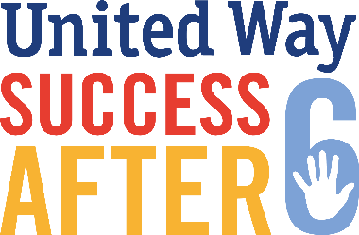
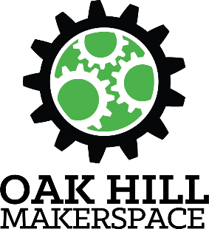
For Immediate Release:
October 4, 2017
Contact Information:
Patrick V. Kerrigan
Executive Director
Oak Hill Collaborative
(330) 518-5884
oakhillcollaborative@gmail.com

Oak Hill Collaborative Launches “Raspberry Pi” Micro-computer Program
Together with the United Way’s Success After 6 Initiative
Youngstown Area Youth Program Expands to Learn Skills Bridging the Digital Divide

YOUNGSTOWN, Ohio – The Oak Hill Collaborative is proud to be launching the next, expanded round of their acclaimed Raspberry Pi (RPi) Program as an education and enrichment partner with the United Way’s Success After 6 early childhood education initiative. They are taking the Raspberry Pi Program to five Youngstown City Schools this fall. A total of 17 classes will be taught this academic year.
This is the second year working with Success After 6 in a series of programs which help to bridge the digital divide by serving those children who may have limited access to the internet and other key technologies by teaching them technology skills and then making the internet accessible through the Raspberry Pi devices they are learning to build and program themselves.
The Raspberry Pi (RPi) is a credit card-sized, complete Linux computer originally designed for education, that plugs into a TV or monitor, and a keyboard and mouse. It is a capable little computer which can be used in electronics projects, and for many of the things that your desktop PC does, like spreadsheets, word processing, browsing the internet, and playing games. It also plays high-definition video. Students successfully completing the program are given their Raspberry Pi devices.
The RPi was inspired by the 1981 BBC Micro. Creator Eben Upton's goal was to create a low-cost device that would improve programming skills and hardware understanding at the pre-university level. Adopted by tinkerers, makers, and electronics enthusiasts for projects that require more than a basic microcontroller, its popularity has grown exponentially.
This year’s first round of classes will be at 5 Youngstown City Schools (Williamson, Taft, Martin Luther King, McGuffey, and Paul C. Bunn). They began on October 2nd with additional classes planned for winter and spring. The goal is to include all city schools next year.
###

The Oak Hill Collaborative’s mission is “to promote economic development and community revitalization through small business development, neighborhood improvement and beautification, and an innovative Makerspace, that serves the Oak Hill corridor, the South Side, and the City of Youngstown as a whole.”
The Collaborative has become an essential advocate for the area’s neighborhood organization and beautification efforts, and since opening its doors in early 2014, Oak Hill Collaborative’s small business incubator has assisted more than 20 small businesses with services including: office space, office equipment and supplies, grant writing, networking and mentoring, legal advice, accounting, business planning, marketing, and technical assistance. The Collaborative also provides leadership, meeting space and other efforts for community organizing initiatives.
The Oak Hill Makerspace focuses on technology projects such as 3D printing, robotics, drones, game and app development, and the Raspberry Pi Project, with a target population of inner city residents.
###

